1.0 Introduction: Critical Analysis of Software Engineering Principles 2

1.1 Contextualizing the Application in Modern Software Development 2

1.2 Advancements in Software Engineering and Embraced Development Strategy 2

1.3 Rationale for Technological and Methodological Choices 3

1.4 RESTful API Design & Microservices-Inspired Architecture 3

1.5 JWT-Based Authentication for Security 3

1.6 Docker for Containerization 4

2.0 Project Planning 4

2.1 Architectural Diagram 4

2.2. Sequence/Interaction Diagram 5

Project Timeline and Milestones 8

Risk Assessment and Mitigation Plan 9

3.0 Project Development and Management Process 9

GitHub Repository and Development Logs 9

4.0 Testing, Building, and Containerization 10

Reference 12

**Development Report: Openverse Media Application (MERN Stack)**

# 1.0 Introduction: Critical Analysis of Software Engineering Principles

Openverse Media Application is a web application that allows one to search for open license media based on the openverse API. The app relies on the MERN (MongoDB, Express.js, React.js, Node.js) stack to build the project, leveraging current web development frameworks and software engineering principles to enhance scalability, maintainability, and security. MERN stack is open source and enable the development of high performant web base application which makes it a suitable option for this project.

# 1.1 Contextualizing the Application in Modern Software Development

Web application development has come a long way with the advent of cloud computing, microservices, and API-based architecture. Contemporary web development calls for high-performance, scalable, and user-friendly applications that can easily integrate with third-party services. Openverse Media Application follows the trend by embracing the microservices-influenced architecture in the guise of RESTful APIs, JWT authentication, and Docker-based containerization.

# 1.2 Advancements in Software Engineering and Embraced Development Strategy

Current software development focuses on modularity, component-oriented design, and state management system implementation to enable the delivery of a better user experience. Sommerville (2020) argues that by employing a disciplined software development process, reusability and maintainability of code are enhanced. The MERN stack is supported by its flexibility and effectiveness in offering full-stack JavaScript development. The one-language JavaScript paradigm facilitates natural data sharing between frontend and backend without context-switching overhead (Richards et al., 2022).

One of the most important methodology choices was Redux Toolkit for handling state. Redux has been broadly used for managing global state, especially where there are complex data flows needed (Dan Abramov, 2015). With Redux Toolkit usage, state mutations become simpler for better performance and avoiding unnecessary re-renders.

# 1.3 Rationale for Technological and Methodological Choices

MERN Stack for Full-Stack Development

* MongoDB: A NoSQL database that provides flexibility in handling media data, making retrieval and storage of data easy (Stonebraker, 2018).
* Express.js: A lightweight framework that simplifies API development, Increase performance and maintainability (Shen, Z., & Spruit, M., 2018).
* React.js: Meta Platforms, Inc. (n.d.) React: A JavaScript library for building user interfaces. Available at: <https://reactjs.org>.
* Node.js: Ensures efficient event-driven, non-blocking I/O operations, making it suitable for real-time applications (Tilkov & Vinoski, 2010).

# 1.4 RESTful API Design & Microservices-Inspired Architecture

The project follows a RESTful API design with a well-defined separation of concerns between frontend and backend. This is in line with contemporary software engineering standards that dictate modularity and scalability (Fielding, 2000). While not a microservices-based architecture in the true sense, the modular architecture guarantees future scalability with eventual evolution into a microservices architecture if needed.

# 1.5 JWT-Based Authentication for Security

Security is a critical requirement of contemporary web applications. JSON Web Token (JWT) authentication facilitates a stateless, scalable security paradigm that reduces database queries while allowing secure API access. This choice is in line with security best practices according to OWASP (2023).

# 1.6 Docker for Containerization

Docker is used to provide a uniform development and deployment environment. Containerization enhances dependency management, deployment automation, and scalability (Merkel, 2014). With more adoption of DevOps practices, Docker makes the Openverse Media Application responsive to cloud deployments.

By adopting modern software engineering principles, the Openverse Media Application demonstrates best practices in full-stack development, security, and performance optimization. The adoption of MERN stack, Redux Toolkit, RESTful APIs, JWT authentication, and Docker is in line with current research and industry practice.

# 2.0 Project Planning

Systematic project planning is important for efficient execution, risk mitigation, and timely delivery of the openverse Media Application. This section outlines the architectural design, user interaction diagrams, project timeline, and risk assessment.

# 2.1 Architectural Diagram

Below is the high-level system architecture:

* Frontend (React.js, Redux Toolkit): Handles UI presentation and state management.
* Backend (Node.js, Express.js): Processes API requests and business logic.
* Database (MongoDB): Stores media search history and user authentication details.
* External API (Openverse API): Provides open-license media search functionality.
* Authentication (JWT): Ensures secure access control.
* Docker & Deployment: Manages the containerized backend and frontend services.

# 2.2. Sequence/Interaction Diagram

A sequence diagram illustrating user interactions:



Search/Filter /Save medias

Login/Register API

Local Storage

Request medias

Openverse DB

Save/Delete media to/from MongoDB

MongoDB

Medias response

**User Authentication:**

* Register a new user→ React UI sends credentials → Express.js validates JWT → MongoDB verifies user.

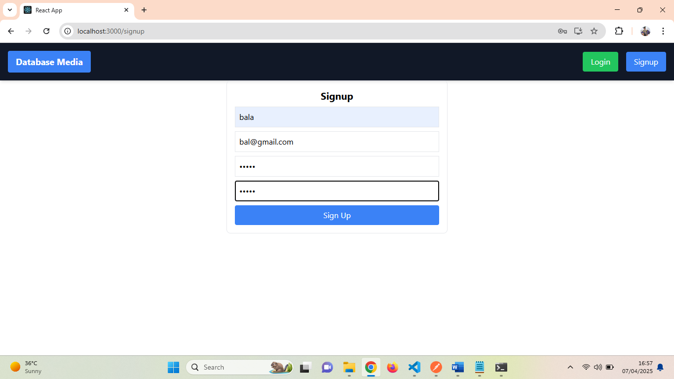

* User logs in → React UI sends credentials → Express.js validates JWT → MongoDB verifies user.

Testing the Login Screen with POSTMAN

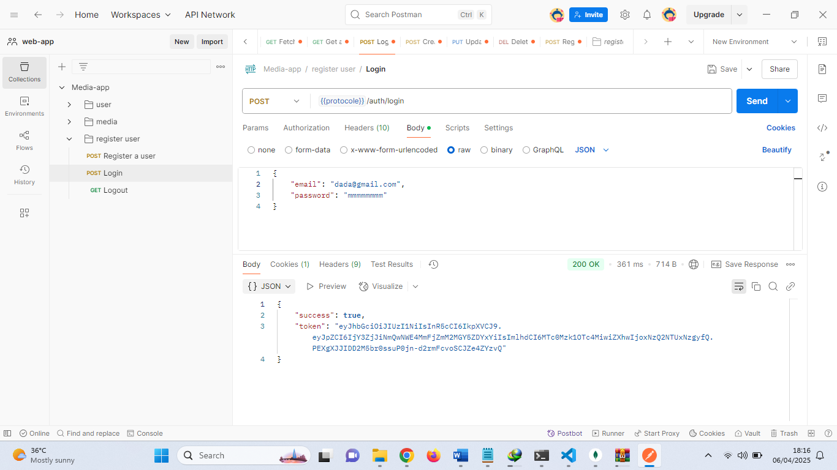

React UI Login Screen

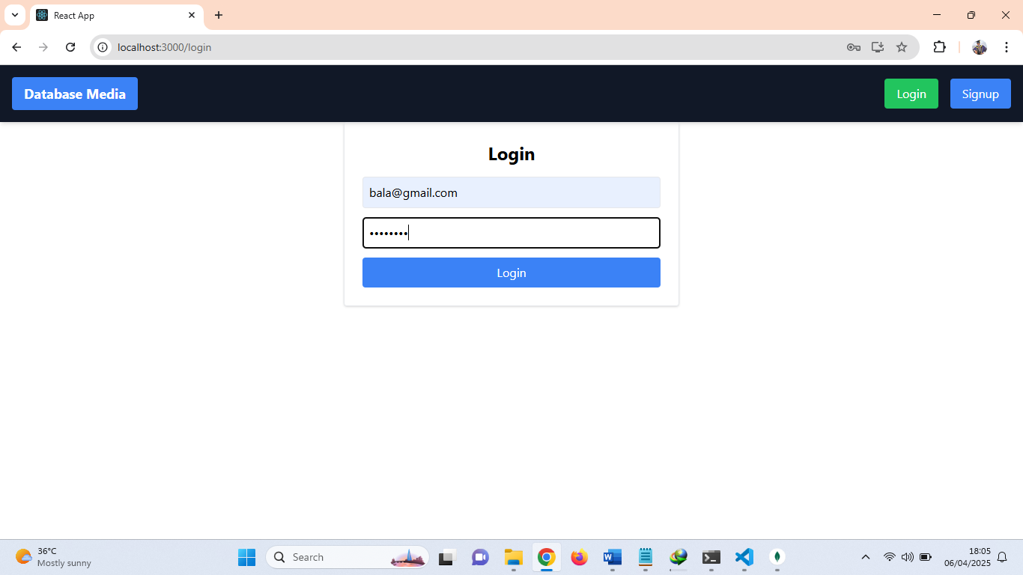

**Media Search:**

* User enters a query → React UI calls backend API → Express.js fetches results from Openverse API → result is stored in local storage.

Fetching array of images from the Openverse API

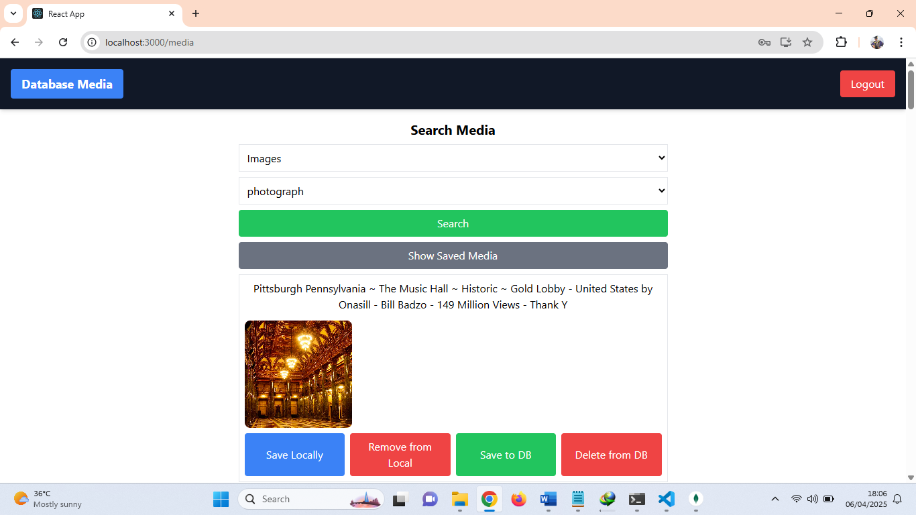

**Media Management:**

* User saves/deletes media → React dispatches Redux action → Express.js updates MongoDB.

Saved information pulled from MongoDB database

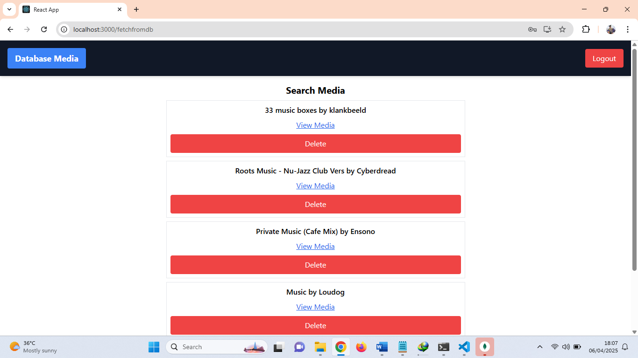

Viewing backend data from MongoDB Compass

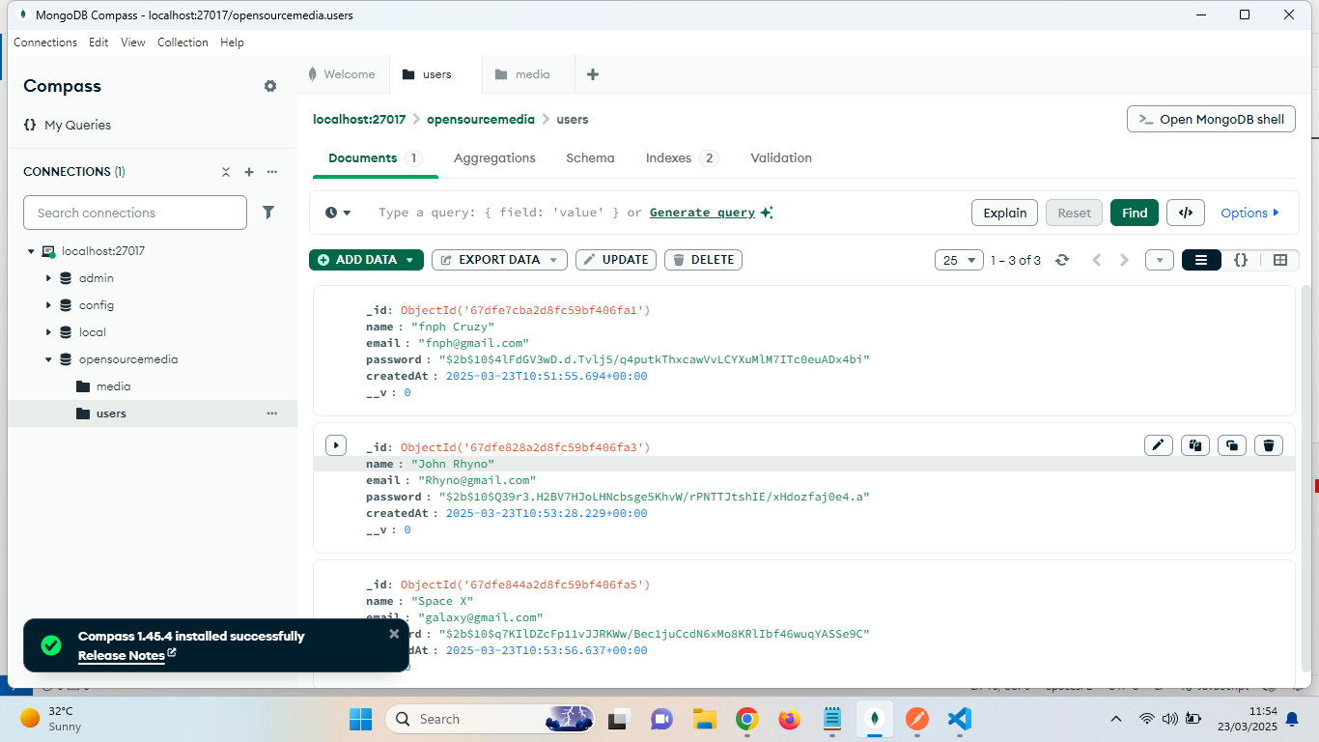

# Project Timeline and Milestones

|  |  |  |
| --- | --- | --- |
| **Phase** | **Task Description** | **Estimated Duration** |
| **Phase 1** | Requirement Analysis & System Design | 1 Weeks |
| **Phase 2** | Backend Development (Node.js, Express, MongoDB) | 1 Weeks |
| **Phase 3** | Frontend Development (React, Redux, Tailwind) | 1 Weeks |
| **Phase 4** | Integration with Openverse API | 3 Days |
| **Phase 5** | Testing & Debugging (POST MAN) | 2 Days |

Total Duration: **3 Weeks and 5 Days**

# Risk Assessment and Mitigation Plan

|  |  |  |
| --- | --- | --- |
| **Risk Factor** | **Potential Impact** | **Mitigation Strategy** |
| API Downtime | Search feature failure | Implement caching and fallback mechanisms |
| Security Vulnerabilities | Data breaches | Use JWT authentication, HTTPS, and validation |
| Performance Bottlenecks | Slow user experience | Optimize database queries, use indexing |
| Unclear Requirements | Scope creep | Regular stakeholder meetings, agile methodology |
| Deployment & Compatibility Issues | Failure in production | Use Docker for consistent environments |

# 3.0 Project Development and Management Process

Effective project management and iterative development processes were central to successful completion of the openverse Media Application. In this section, major areas of the development process, feature driven development, and best practices in software engineering are outlined.

# GitHub Repository and Development Logs

* GitHub Repository with docker containers: https://github.com/IbrahimWale/dockerized-mediaapp
* GitHub Repository without docker: https://github.com/IbrahimWale/media-app
* Commit History and Progress Tracking: The project utilized a formal commit methodology with very lengthy commit messages.
* Agile Methodology: Incremental feature increment development cycle with sprint oriented.
* Documentation & Trade-offs: Written out decisions, i.e., schema evolution of databases and authentication schemes.

Developing ExpressJs API and Routers functionalities

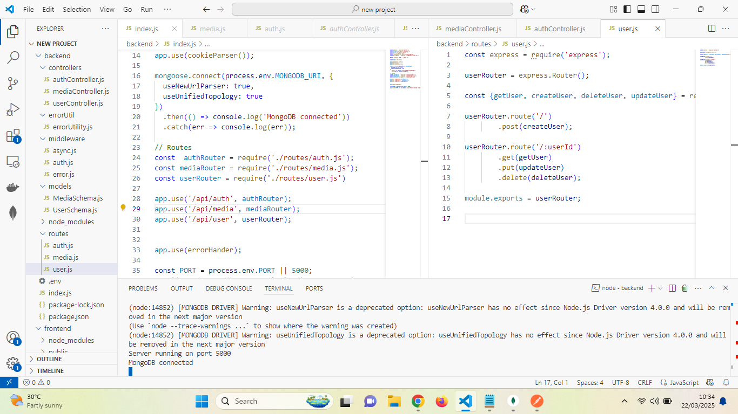

# 4.0 Testing, Building, and Containerization

**4.1 Testing Methodology**

The backend API was tested using Postman to validate endpoints, check authentication mechanisms, and ensure API responses were correct.

Tracing syntax error from log file

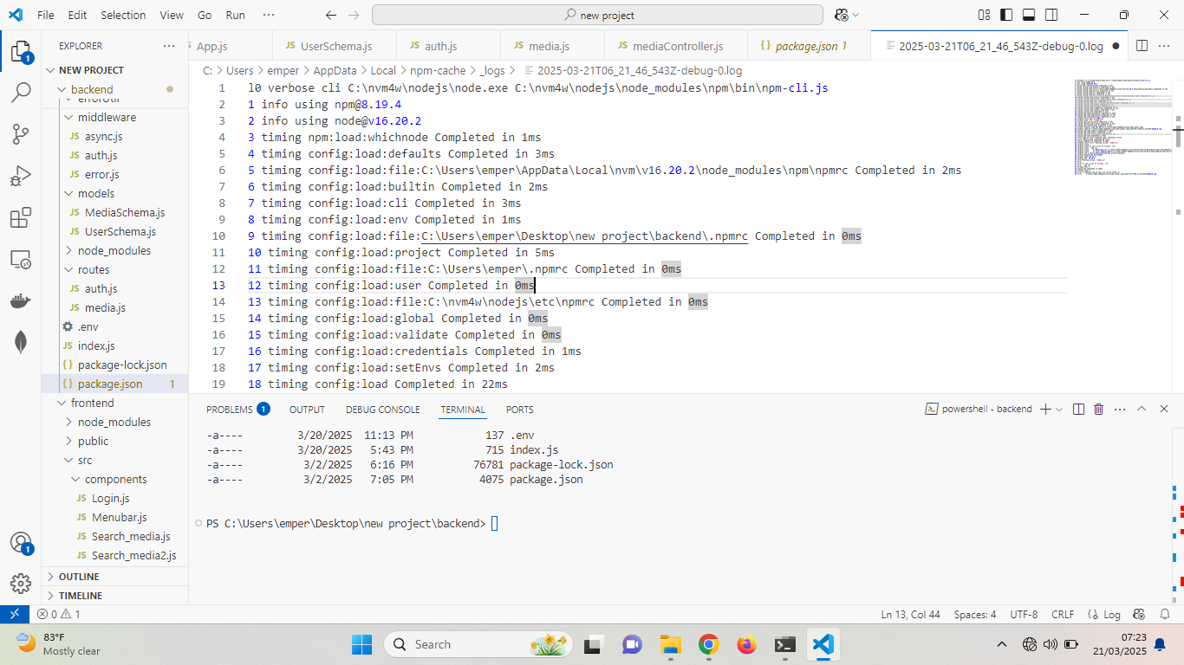

**4.1 Test Cases and Coverage**

* Unit Tests: Covered API routes, authentication flows, and database interactions using POSTMAN.

Evidence of testing and documentation using POSTMAN: https://documenter.getpostman.com/view/42850199/2sB2cX91qQ

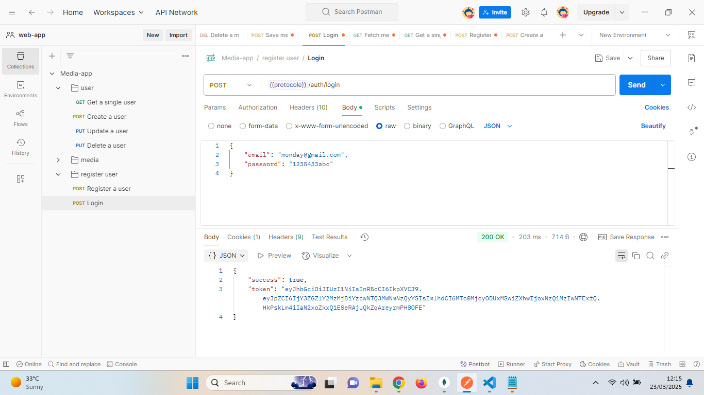

**Containerization Approach**

* Docker Compose was used to orchestrate multi-container setups, ensuring seamless integration between services.
* Scalability: Containers allow horizontal scaling and easy deployment to cloud platforms.

# Reference

1. Shen, Z., & Spruit, M. (2018). A Lightweight API-Based Approach for Building Flexible Clinical NLP Systems. *Journal of Healthcare Engineering*, *2019*(1), 3435609. <https://doi.org/10.1155/2019/3435609>
2. Fielding, R. (2000) ‘Architectural Styles and the Design of Network-based Software Architectures’, *Doctoral Dissertation, University of California, Irvine*.
3. Jones, M., Bradley, J. and Sakimura, N. (2015) ‘JSON Web Token (JWT) Profile for OAuth 2.0 Client Authentication and Authorization Grants’, *RFC 7523*.
4. Jordan, M. (2021) *Mastering React: Build Modern Web Applications with React*. 2nd edn. New York: Packt Publishing.
5. Merkel, D. (2014) ‘Docker: Lightweight Linux Containers for Consistent Development and Deployment’, *Linux Journal*, 2014(239), pp. 2–7.
6. Richards, C., Gupta, A. and Kim, S. (2022) ‘JavaScript for Full-Stack Development: Best Practices and Challenges’, *Software Engineering Journal*, 35(3), pp. 145–162. doi:10.1007/00500-022-06691-4.
7. Sommerville, I. (2020) *Software Engineering*. 10th edn. Harlow: Pearson.
8. Stonebraker, M. (2018) ‘SQL versus NoSQL: Which Database Model is Right for Your Application?, *Communications of the ACM*, 61(3), pp. 36–45. doi:10.1145/3186726.
9. Tilkov, S. and Vinoski, S. (2010) Node.js: Using JavaScript to Build High-Performance Network Programs’, *IEEE Internet Computing*, 14(6), pp. 80–83. doi:10.1109/MIC.2010.147.